7-66

Main Question (สำหรับแสดงข้อสอบ)

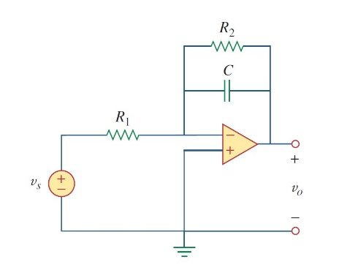

Given*Vs* = 1 V at t=0 , *R*1 = 20000 Ω, *R*2 = 50000 Ω, C= 0.5 nF.

Find

Variables (สำหรับเขียนโค้ดเพื่อหาคำตอบ)

Random variables

vs = {1:5};

r1 = {1000:50000:1000};

r2 = {1000:50000:1000};

c = {0.5e-9:5e-9:0.5e-9};

time = {1:5};

Global variables

#vs = 1; r1 = 20000; r2= 50000; c = 0.5*e(-9);

# t=0-

vc0 = 0;

# t=inf

vcf = -(r2/r1)*vs;

# t=0+

req = r2;

tau = c*req;

vct = vcf+(vco-vcf)*exp(-t/tau);

Part (กรอกคำตอบ)

1. *vc*(0-) = vo0 = 0 V

At *t* > 0

1. *vc*(∞) = vcf = -2.5 V
2. *τ* = tau = 25x10-3 s
3. *vc*(*t*) = vcf+(vco-vcf)*exp(-t/tau)= -2.5+2.5*exp^(-t/25x10-3) V

7-67

Main Question (สำหรับแสดงข้อสอบ)

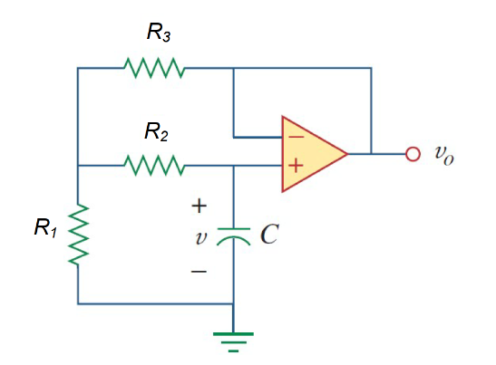

Given*v(0)* = 5 V, *R*1 = 10000 Ω, *R*2 = 10000 Ω, *R*3 = 10000 Ω C= 1 µF.

Find

Variables (สำหรับเขียนโค้ดเพื่อหาคำตอบ)

Random variables

v = {1:10};

r1 = {1000:20000:1000};

r2 = {1000:20000:1000};

r3 = {1000:20000:1000};

c = {100e-9:500e-9:100e-9};

Global variables

# v = 5; r1 = 10000; r2= 10000; r3= 10000; c = 1*e(-6);

# t=0-

vo0n = 0;

# t=inf

vof = 0;

# t=0+

vo0p = v;

req = r1+(r2+r3)/(r2*r3);

tau = c*req;

vot =vof+(v-vof)*exp(-t/tau);

Part (กรอกคำตอบ)

1. *vc*(0-) = vo0n = 0 V

At *t* > 0

1. *vc*(∞) = vof = 0V
2. *vc*(0+) = vo0p = 5V
3. *τ* = tau = 0.015 s
4. *vc*(*t*) = vcf+(vco-vcf)*exp(-t/tau)= 5*exp^(-t/15x10-3)

7-69

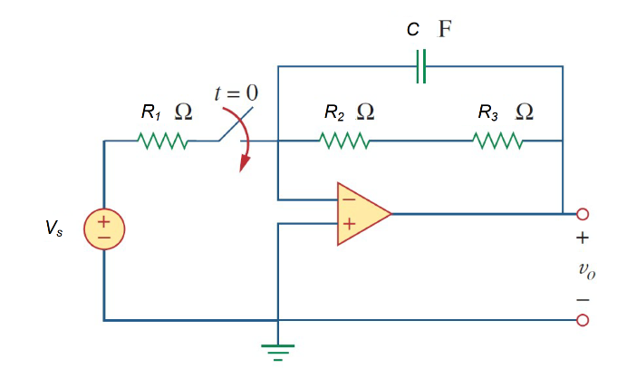

Given*Vs* = 4 V, *R*1 = 10kΩ,

*R*2 = 20 kΩ, *R*3 = 100kΩ, C= 25 mF.

Find

Variables (สำหรับเขียนโค้ดเพื่อหาคำตอบ)

Random variables

vs = {1:10};

r1 = {1000:10000:1000};

r2 = {1000:20000:1000};

r3 = {100000:100000:10000};

c = {5e-3:30e-3:5e-3};

Global variables

#vs =4;r1 = 10000; r2= 20000;

r3= 100000; c = 25*e(-3);

# t=0-

vo0 = 0;

# t=inf

vof =-((r2+r3)/r1)*vs;

# t=0+

req = r2+r3;

tau = c*req;

vot = vof+(vo0-vof)*exp(-t/tau);

Part (กรอกคำตอบ)

1. *vo*(0-) = vo0 = 0 V

At *t* > 0

1. *vo*(∞) = vof = -48 V
2. *τ* = tau = 3000 s
3. *vo*(*t*) = vof+(vo0-vof)*exp(-t/tau)= -48+48*exp^(-t/3000) V

7.71

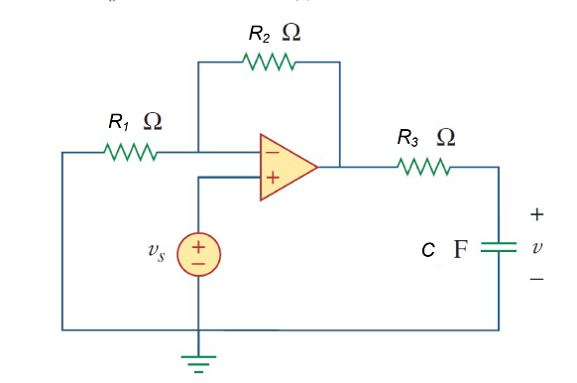

Given *Vs* = 3 V, *R*1 = 10Ω, *R*2 = 10 Ω, R3=20k Ω,C= 20 µF

Find

Variables (สำหรับเขียนโค้ดเพื่อหาคำตอบ)

Random variables

r1 = {1000:20000:1000};

r2 = {1000:20000:1000};

r3 = {1000:20000:1000};

c = {10e-6:50e-6:10e-6};

vs= {1:5};

Global variables

#vs =3; r1 = 10000; r2= 10000; r2= 20000; c = 20*e-6;

is =0.5

# t=0-

vc0 = 0

# t=inf

vcf = ((r2/r1)+1)*vs;

# t=0+

req = r3;

tau = c*req;

vct = vcf+(vc0-vcf)*exp(-t/tau);

Part (กรอกคำตอบ)

1. *vc*(0-) = vc0 = 0 V

At *t* > 0

1. *vc*(∞) = vcf = 6 V
2. *τ* = tau = 0.2 s
3. *vc*(*t*) = vcf+(vc0-vcf)*exp(-t/tau)= 6-6*exp^(-t/0.2) V

7.72

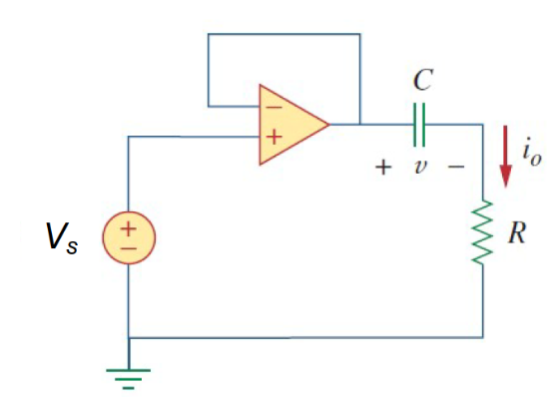

Given *Vs* = 3u(t) V, *v(0)*= -2Ω, *R* = 10 kΩ,C= 10 µF

Find

Variables (สำหรับเขียนโค้ดเพื่อหาคำตอบ)

Random variables

r = {1000:20000:1000};

c = {10e-6:50e-6:10e-6};

vs= {1:5};

Global variables

#vs =3; v0 = -2; r= 10000;c = 10*e-6;

# t=0-

vo0 = -2

# t=inf

vf = vs;

# t=0+

req = r;

tau = c*req;

vt = vf+(v0-vf)*exp(-t/tau);

io = c*(v0-vf)*(-1/tau) *exp(-t/tau);

Part (กรอกคำตอบ)

1. *v*(0-) = v0 = -2 V

At *t* > 0

1. *v*(∞) = vof = 3 V
2. *τ* = tau = 0.1 s
3. *v*(*t*) = vf+(v0-vf)*exp(-t/tau)= 3-5*exp^(-t/0.1) V
4. *io*(*t*) = c*(v0-vf)*(-1/tau) *exp(-t/tau)= 0.5*exp^(-t/0.1) V